HONORS CHEMISTRY • UNIT 8
Intermolecular Forces
Why water is a liquid but methane is a gas, why some liquids evaporate in seconds and others cling to a surface — it all comes down to the attractions BETWEEN molecules.

TEACHER EDITION
Everything in a light-gray box or cell is an answer or model response. Teacher notes (misconceptions, demo ideas, discussion prompts, sources) appear in the heavy-bordered boxes labeled TEACHER NOTE. The pages follow the student packet, so they line up closely.

What we will learn
8.1 | London dispersion forces
8.2 | Identifying the intermolecular force (dipole–dipole, hydrogen bonding)
8.3 | IMFs and the properties of liquids
8.4 | Putting it all together: boiling point, volatility, ΔHvap
★ | Extra practice & unit review

By the end of this unit I can…
• Distinguish between intramolecular and intermolecular forces and show each on a drawing.
• Explain how London dispersion forces form, why every molecule has them and why they get stronger as molecules get bigger.
• Decide whether a molecule is polar, and list every IMF it can form (LDF, dipole–dipole, hydrogen bonding).
• Draw two molecules and show the attraction between them.
• Relate IMF strength to boiling point, evaporation rate (volatility), drop shape and enthalpy of vaporization.
• Rank substances by boiling point and justify the ranking with IMFs.
• Use ΔHvap, molar mass and gas-volume relationships in calculations.
Unit at a glance (teacher)
Topic | Suggested pacing | Depth the homework expects
8.1 LDF | 1–2 days | Intra vs intermolecular; LDF origin (temporary dipole), why weakest, all molecules have them; boiling point trend of C₃H₈, C₅H₁₂, C₈H₁₈.
8.2 Identifying IMFs | 2 days | Lewis structure → polarity → IMF for H₂O, CH₃Cl, CH₄, CCl₄, CO, CS₂, H₂S, HF, O₂, diethyl ether, HCN; temporary vs permanent dipole; draw two CH₃Cl.
8.3 Properties | 1–2 days | Drop shapes (surface tension) for water, pentane, acetone; evaporation; draw H-bonding between 2 water molecules and ethanol/water.
8.4 Putting it together | 1–2 days | Rank HF, O₂, CO₂; most volatile (C₂H₆, H₂O, CH₃OH); CCl₄ vs CH₄; ΔHvap calculation (10.0 g CCl₄); propane at STP and combustion energy.

TEACHER OVERVIEW
Big picture. This unit is where Unit 3’s shape and polarity pay off. The whole unit reduces to one habit: Lewis structure → shape → polar? → list ALL IMFs → compare strength (and size) → predict property.
Misconceptions to watch for:
• Confusing bonds with IMFs: boiling water breaks IMFs, NOT the O–H covalent bonds.
• “Hydrogen bonding is a bond.” It is an attraction between molecules (about 5–10% of a covalent bond’s strength).
• “Any molecule with H and O or N can hydrogen-bond.” The H must be directly bonded to N, O or F (CH₃Cl, H₂S and HCN do NOT hydrogen-bond; the H in CH₃CH₂–O–CH₂CH₃ is bonded to C).
• Saying non-polar molecules have no IMF at all (they have LDF).
• Always giving LDF as the “main” IMF of a polar molecule. LDF is present in every molecule; ‘main’ means the strongest type present.
• Forgetting size: a large non-polar molecule can have a higher boiling point than a small polar one (e.g., CCl₄, 76 °C, vs HCl, −85 °C).
• Describing LDF as “the electrons move to one side.” It is a temporary, instantaneous dipole created by random electron motion that induces a dipole in a neighbor.

IMAGES
Image spots: the two HF structure choices in 8.1, the three drop drawings in 8.3 and the ethanol–water choices come from the homework; use the IMAGE GOES HERE frames if you want the originals.

8.1 | London Dispersion Forces Intramolecular vs intermolecular • temporary dipoles • size and boiling point

BIG IDEA
There are forces inside molecules (the covalent bonds that hold atoms together) and forces between molecules (intermolecular forces, IMFs). Changes of state, like boiling, break the forces between molecules; they do not break the bonds inside them.

Key vocabulary — write each definition in your own words
Term | Definition (your words) | Example / sketch
Intramolecular force | An attraction inside a molecule that holds its atoms together: a chemical (covalent) bond. | The H–F bond in HF
Intermolecular force (IMF) | An attraction BETWEEN separate molecules. IMFs are much weaker than covalent bonds. | The attraction between two HF molecules
Temporary (instantaneous) dipole | A short-lived separation of charge that happens when the electrons in a molecule are momentarily unevenly distributed. | A nonpolar Cl₂ for a split second
Induced dipole | A dipole created in a molecule because a neighboring dipole pushes or pulls its electrons to one side. | The neighbor of a temporary dipole
London dispersion force (LDF) | The attraction between a temporary dipole and an induced dipole. Every molecule (and atom) has LDF. | The only IMF in CH₄ and Ne
Polarizability | How easily the electron cloud of a molecule can be distorted. Larger electron clouds (more electrons) are more polarizable, so they have stronger LDF. | I₂ is more polarizable than F₂

Intramolecular vs intermolecular
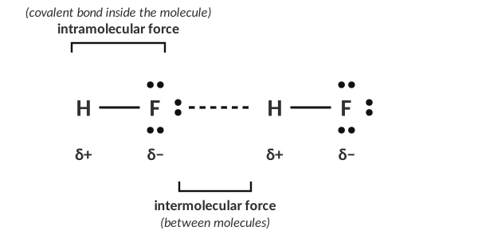
Two HF molecules: the solid line is the bond inside a molecule; the dashed line is the attraction between molecules.
1. An intramolecular force is considered a ____________________. How is it represented in a Lewis diagram?
A chemical bond (covalent). It is drawn as a line (a shared pair of electrons) between two atoms.

2. Complete the Lewis structure for HF, then draw an arrow to the intramolecular force.
H–F with three lone pairs on F (H has none); the arrow points to the line between H and F.

3. Where does an intermolecular force occur?
Between two (or more) separate molecules: in the space between them, not within them.

4. Why can two molecules be attracted to each other? What causes an IMF?
Molecules contain positive nuclei and negative electrons. Whenever the charges are unevenly distributed, even briefly, the positive part of one molecule is attracted to the negative part of its neighbor. IMFs are electrostatic (Coulomb) attractions between partial charges.

[ IMAGE GOES HERE ]
Optional: the 'which diagram shows an IMF?' choices from the homework

THINK OF IT LIKE… HOLDING HANDS VS. HOLDING A HAND-TIED ROPE
Imagine each molecule is a group of friends tied together with strong rope (the covalent bonds). The friends in different groups can only hold hands loosely (IMFs). Pulling the groups apart (boiling) only lets go of the hands; the rope stays tied.

How London dispersion forces form
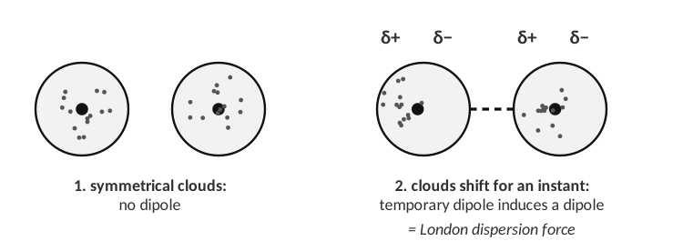
Temporary dipole → induced dipole → attraction.
CUES / KEY WORDS  Step 1  Step 2  Step 3 | DESCRIBE HOW TWO NON-POLAR MOLECULES COME TO ATTRACT EACH OTHER  1. Electrons are always moving, so at any instant the electron cloud of one molecule can be slightly more on one side → a temporary dipole (δ+ on one side, δ− on the other).  2. The δ− end repels the electrons of a neighboring molecule, so that molecule’s cloud shifts → an induced dipole.  3. The δ+ end of one molecule attracts the δ− end of the other: a weak, short-lived attraction. Because electrons keep moving, the dipoles keep forming and changing all the time.

5. Why are LDFs the weakest of the intermolecular forces? Your answer should discuss the dipole that is formed.
The dipoles are temporary and very small: they last for a tiny fraction of a second and the partial charges are small, so the attraction is weak compared with the permanent dipoles in polar molecules.

6. Explain why ALL molecules form LDF.
All molecules and atoms contain moving electrons, so any molecule can form a temporary dipole and induce one in its neighbor.

7. Which molecules form only LDF as their main intermolecular force?
Non-polar molecules: e.g., noble gases (He, Ne), diatomic elements (O₂, N₂, Cl₂), symmetrical molecules (CO₂, CH₄, CCl₄) and hydrocarbons (alkanes).

Size matters: LDF and boiling point
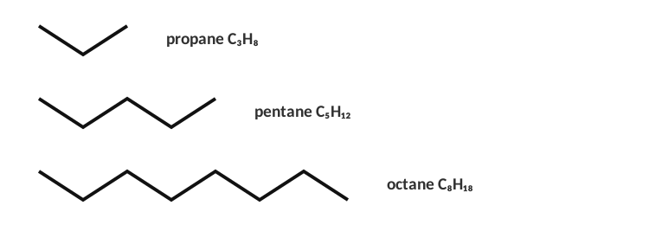
Three alkanes (skeletal structures: each corner is a carbon with enough hydrogens to make four bonds).
Formula | Number of electrons | State at room temp. | Boiling point
C₃H₈ | 26 | gas | −42 °C
C₅H₁₂ | 42 | liquid | 36 °C
C₈H₁₈ | 66 | liquid | 125 °C

8. What trend do you notice between the size of the molecule and the boiling point?
The larger the molecule (more carbons, more electrons), the higher the boiling point.

9. Each molecule forms only LDF. Explain what causes the trend.
Bigger molecules have more electrons and a larger, more polarizable electron cloud, so temporary dipoles are larger and more easily induced; they also have more surface area in contact with their neighbors. Stronger LDF means more energy (a higher temperature) is needed to separate the molecules into a gas.

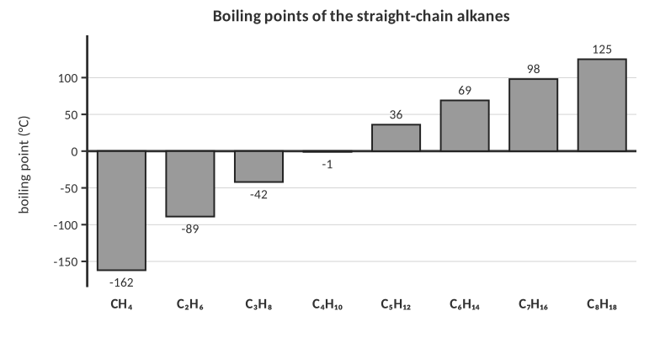
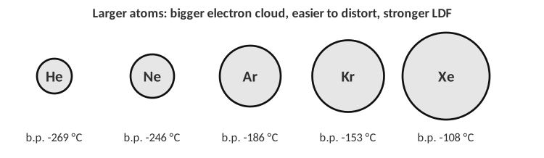
10. Predict: which has the higher boiling point, F₂ or Br₂? Which is a gas at room temperature? Explain.
Br₂ has the higher boiling point (59 °C vs −188 °C). Both are non-polar, but Br₂ has many more electrons (70 vs 18), so stronger LDF. F₂ is the gas; Br₂ is a liquid at room temperature.

TEACHER NOTE
Branching decreases LDF: pentane boils at 36 °C but 2,2-dimethylpropane (neopentane) at 9.5 °C, because a compact molecule has less surface area for contact. Optional enrichment for fast finishers. Real boiling points: CH₄ −162, C₂H₆ −89, C₃H₈ −42, C₄H₁₀ −1, C₅H₁₂ 36, C₆H₁₄ 69, C₇H₁₆ 98, C₈H₁₈ 125 °C; noble gases He −269, Ne −246, Ar −186, Kr −153, Xe −108 °C.

11. An intramolecular force is…
A) the attraction between two molecules
B) a chemical bond within a molecule
C) only found in ionic compounds
D) the same as an LDF

12. Which has the strongest London dispersion forces?
A) CH₄ B) C₂H₆ C) C₄H₁₀ D) C₈H₁₈
13. Boiling a liquid such as water breaks…
A) the covalent bonds within molecules
B) the intermolecular forces between molecules
C) both equally
D) neither

14. Which of these only forms LDF?
A) H₂O B) CH₃Cl C) N₂ D) HF
8.2 | Identifying the Intermolecular Force Polarity → IMFs • dipole–dipole • hydrogen bonding

BIG IDEA
To find a molecule’s IMFs: draw the Lewis structure, decide the shape, and decide whether it is polar. Every molecule has LDF; polar molecules add dipole–dipole; molecules with H bonded to N, O or F add hydrogen bonding.

Key vocabulary — write each definition in your own words
Term | Definition (your words) | Example / sketch
Permanent dipole | A dipole that is always there because the molecule is polar (uneven sharing of electrons that does not cancel). | H₂O, CH₃Cl, HF
Dipole–dipole force | The attraction between the δ+ end of one polar molecule and the δ− end of a neighboring polar molecule. | Between two CH₃Cl molecules
Hydrogen bonding | A strong dipole–dipole attraction between a hydrogen that is directly bonded to N, O or F in one molecule and a lone pair on N, O or F of a neighboring molecule. | Between H₂O molecules
Non-polar molecule | A molecule with no permanent dipole (bond dipoles cancel or the bonds are non-polar). Only LDF; it can have temporary dipoles. | CO₂, CH₄
Main IMF | The strongest type of IMF the molecule forms: hydrogen bonding > dipole–dipole > LDF. | Water: hydrogen bonding

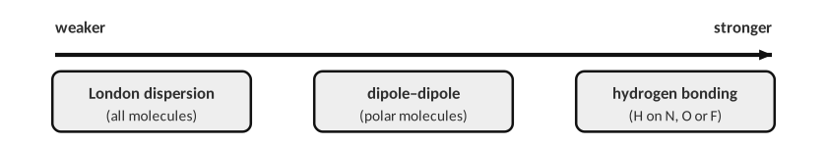
Dipole–dipole
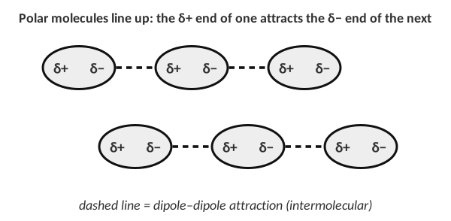
Polar molecules orient so opposite partial charges are close.
1. Why is dipole–dipole stronger than LDF for molecules of similar size?
A permanent dipole is always present and is larger than a temporary dipole, so the δ+/δ− attraction is stronger and constant.

Hydrogen bonding
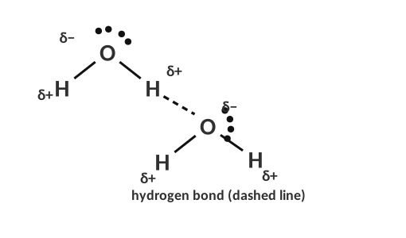
Hydrogen bonding between two water molecules.
HYDROGEN BONDING CHECKLIST
1. The molecule has a hydrogen directly bonded to N, O or F (look for N–H, O–H, F–H).
2. A neighboring molecule has a lone pair on N, O or F that the hydrogen can point to.
3. If an H is bonded to C (C–H), or the molecule has N, O or F but no N–H/O–H/F–H, there is no hydrogen bonding.

THINK OF IT LIKE… A MAGNET-STRONG HANDSHAKE
Hydrogen is tiny and, when bonded to N, O or F, its single electron is dragged away, leaving an almost bare proton. That bare end can get very close to a lone pair on a neighbor, so the attraction is much stronger than an ordinary dipole–dipole attraction.

The IMF flowchart
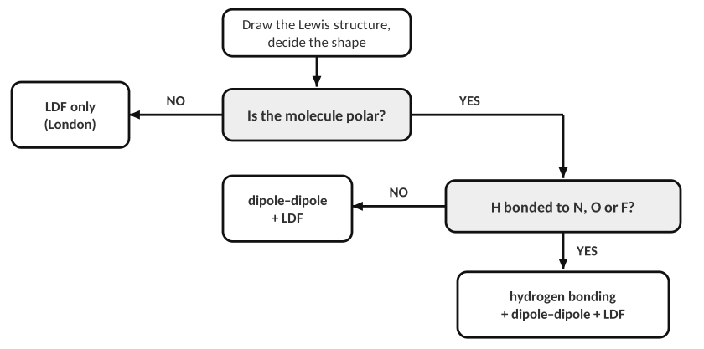
Remember: LDF is present in EVERY case.
Three molecules, three IMFs
Complete the table. Draw the Lewis structure, label the molecule polar or non-polar, give the main IMF, and say whether the molecule has a temporary or a permanent dipole.
Substance | Lewis structure | Polarity | Main IMF | Dipole type | Boiling point
Water (H₂O) |  | polar | hydrogen bonding | permanent | 100 °C
Methyl chloride (CH₃Cl) |  | polar | dipole–dipole | permanent | −24 °C
Methane (CH₄) |  | non-polar | LDF | temporary | −161 °C

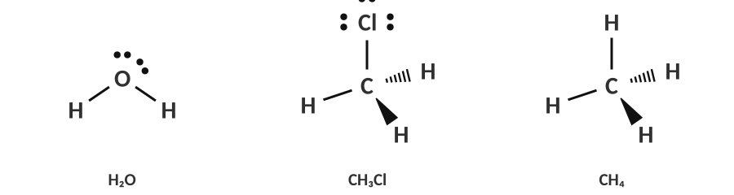
Answers: H₂O (bent), CH₃Cl (tetrahedral), CH₄ (tetrahedral)
2. Draw two CH₃Cl molecules and show the attraction between them. Label the partial charges.
Two CH₃Cl molecules oriented so the δ− Cl end of one is near the δ+ (C/H) end of the other; a dashed line between them is the dipole–dipole attraction.

3. Using the strength of the IMFs, explain the boiling point differences in the table.
Water has hydrogen bonding (strongest IMF), so it boils at 100 °C; CH₃Cl has dipole–dipole forces, which are weaker, so it boils at −24 °C; methane has only LDF (weakest), so −161 °C. The stronger the IMF, the more energy is needed to separate the molecules.

Practice: draw, classify, and list ALL IMFs
For each molecule, draw the Lewis structure, decide polar or non-polar, and write every IMF it forms.
Molecule | Lewis structure | Polarity | All IMFs
Carbon tetrachloride, CCl₄ |  | non-polar | LDF
Carbon monoxide, CO |  | polar | dipole–dipole, LDF
Carbon disulfide, CS₂ |  | non-polar | LDF
Hydrogen sulfide, H₂S |  | polar | dipole–dipole, LDF
Hydrogen fluoride, HF |  | polar | hydrogen bonding, dipole–dipole, LDF
Oxygen gas, O₂ |  | non-polar | LDF
Diethyl ether, (CH₃CH₂)₂O |  | polar | dipole–dipole, LDF (no O–H, so no H-bonding)
Hydrogen cyanide, HCN |  | polar | dipole–dipole, LDF (H is on C, not N)

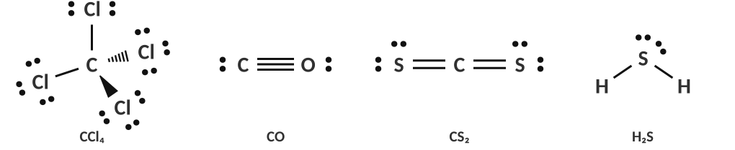
Answers: CCl₄, CO, CS₂, H₂S
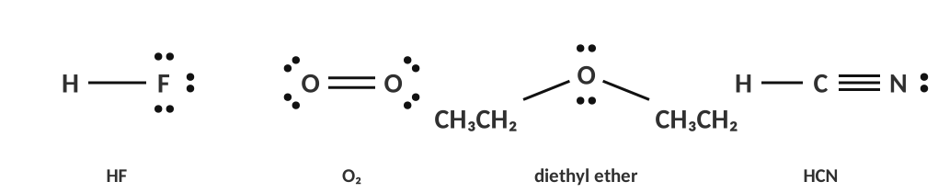
Answers: HF, O₂, diethyl ether, HCN
TEACHER NOTE
Common slips: HCN — the H is bonded to carbon, so no hydrogen bonding (dipole–dipole + LDF). H₂S — S is not electronegative enough; no hydrogen bonding. Diethyl ether has an O but no O–H, so it accepts but cannot donate H-bonds with itself (its pure-liquid IMFs are dipole–dipole + LDF). CO is only weakly polar; accept dipole–dipole + LDF.

4. Which molecule can form hydrogen bonds with other molecules of its own kind?
A) CH₄ B) CH₃Cl C) NH₃ D) H₂S
5. Which of these has only LDF?
A) HCl B) CCl₄ C) NH₃ D) H₂O
6. The main IMF in CH₃Cl is…
A) LDF B) dipole–dipole C) hydrogen bonding D) ionic bonding
7. Which molecule has a temporary dipole only?
A) H₂O B) HF C) CH₄ D) CH₃Cl
8.3 | IMFs and the Properties of Liquids Surface tension • evaporation • volatility • hydrogen-bond drawings

BIG IDEA
The stronger the IMFs, the harder it is for molecules to leave the liquid or slide past each other. So strong IMFs mean: higher boiling point, lower volatility (evaporates slowly), lower vapor pressure, higher surface tension and higher viscosity.

Property | What it means | Strong IMF → ?
Boiling point | temperature at which vapor pressure = outside pressure | higher
Volatility / evaporation rate | how quickly a liquid turns to vapor | lower
Vapor pressure | pressure of the vapor above a liquid at equilibrium | lower
Surface tension | how strongly the surface resists being broken (beads up) | higher
Viscosity | resistance to flow (thickness) | higher
ΔHvap | energy needed to vaporize 1 mol of liquid | higher

LAB CORNER • Three drops on a flat surface

A student places 1 drop of each substance (water, pentane and acetone) on a flat surface and draws what they see. The drawings are not labeled with the names.
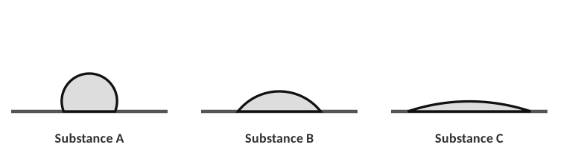
[ IMAGE GOES HERE ]
Optional: the three Lewis structures (water, pentane, acetone) from the homework

Molecule | Main IMF | Prediction: drop shape
Water | hydrogen bonding | tall bead (A)
Acetone (CH₃)₂C=O | dipole–dipole | medium (B)
Pentane C₅H₁₂ | LDF | flat, spread out (C)

1. What property is this student testing? How can the student figure out which drop is which substance?
Surface tension (and cohesion). The stronger the IMFs, the more the molecules pull toward each other and the more the drop beads up: strongest IMF (water) = tallest drop, weakest (pentane) = flattest.

2. Identify Substance A, B and C. Then explain which of the three would evaporate fastest if left out for 10 minutes.
A = water, B = acetone, C = pentane. Pentane evaporates first: it has only LDF, the weakest IMF, so its molecules escape into the gas phase most easily. (Water has the strongest IMF and evaporates slowest.)

Drawing hydrogen bonds
3. Draw two water molecules and show how they are attracted to each other (label δ+, δ− and the hydrogen bond).
O δ− of one molecule and an H δ+ of the other, joined by a dashed line (the hydrogen bond), with the H lying roughly on the line O–H···O.

The structure of ethanol is CH₃CH₂–O–H. Which diagram correctly shows how ethanol hydrogen-bonds with water? (Dashes = hydrogen bond.)
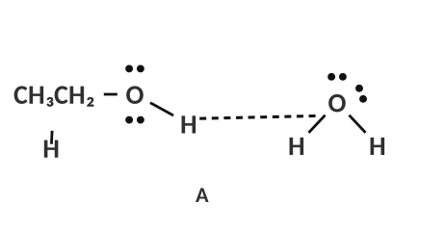 | 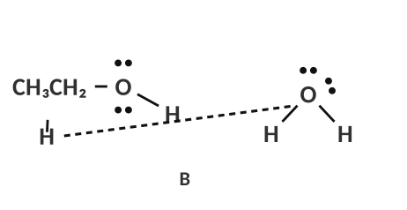 | 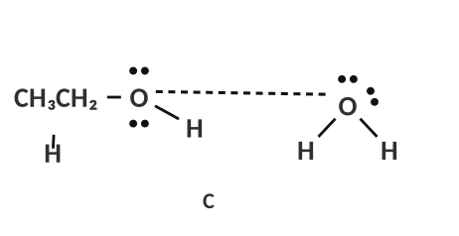
A | B | C

4. Circle the correct diagram and explain why the other two are wrong.
A is correct: the H bonded to O in ethanol (δ+) is attracted to the lone pair on water’s O (δ−). B uses an H bonded to carbon (not N, O or F); C joins two oxygen atoms (δ− with δ−: they repel). (Water’s H pointing to ethanol’s O would also be a correct hydrogen bond.)

LAB CORNER • Evaporative cooling

Three thermometers are wrapped in cotton soaked with Liquid A, B or C (water, pentane or acetone in some order). All start at 22.0 °C and are held in the air for 3 minutes.
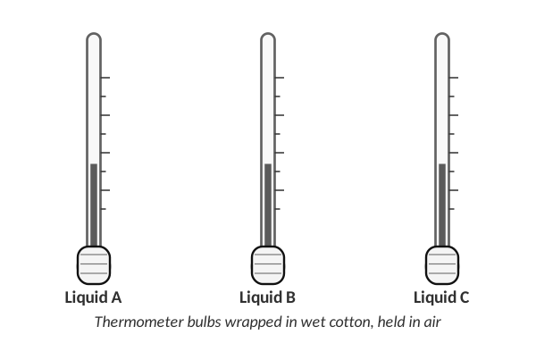
Liquid | Start (°C) | After 3 min (°C) | Change (°C) | Which liquid? (water / acetone / pentane)
A | 22.0 | 3.0 | −19.0 | pentane
B | 22.0 | 8.5 | −13.5 | acetone
C | 22.0 | 18.5 | −3.5 | water

5. Complete the table, then identify each liquid. Explain how evaporation cools the thermometer and why the liquid with the weakest IMF cooled the most.
Evaporation takes the highest-energy molecules (they can overcome the IMFs and escape), so the energy that leaves the liquid cools the thermometer. A liquid with weak IMFs (pentane) evaporates fastest, so it removes energy fastest and cools the most. Water’s strong hydrogen bonds make it evaporate slowly (smallest cooling).

TEACHER NOTE — LAB
Sample data (typical for 3-minute trials with filter paper or cotton): pentane ≈ −15 to −20 °C change, acetone ≈ −10 to −15 °C, ethanol ≈ −8 to −10 °C, water ≈ −3 to −5 °C. Safety: no flames (pentane, acetone and ethanol are flammable), good ventilation, goggles. Hexane or hexanes can replace pentane. Students may also wrap the bulb with filter paper and a rubber band.

6. Which liquid should have the highest surface tension?
A) pentane B) acetone C) water D) hexane
7. Which substance is the most volatile?
A) C₂H₆ B) H₂O C) CH₃OH D) NaCl(aq)
8.4 | Putting It All Together Ranking • boiling point • ΔHvap • calculations

BIG IDEA
When comparing substances: (1) list every IMF each one has; (2) compare the strongest type (hydrogen bonding > dipole–dipole > LDF); (3) if the type is the same, the one with more electrons (bigger molecules) wins.

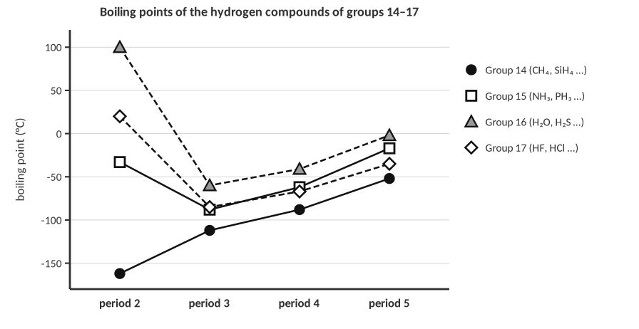
1. Look at the graph. In groups 14, 15, 16 and 17 the boiling point generally increases down a group. Why? Which three compounds break this trend and what do they have in common?
Down a group the molecules are larger with more electrons, so LDF increase and so does the boiling point. NH₃, H₂O and HF are the exceptions: they are far higher than expected because their molecules form hydrogen bonds (H bonded to N, O or F). Group 14 (CH₄ …) shows the pure LDF trend because those molecules are non-polar.

2. Place the molecules in order of increasing boiling point: HF, O₂, CO₂. _________ < _________ < _________
O₂ < CO₂ < HF. O₂ (−183 °C) and CO₂ (sublimes at −78 °C) are non-polar with only LDF; CO₂ has more electrons (22 vs 16) so stronger LDF. HF (20 °C) forms hydrogen bonds, the strongest IMF.

3. Which substance will be the most volatile (highest evaporation rate): (a) C₂H₆ (b) H₂O (c) CH₃OH? Explain.
(a) C₂H₆. It is non-polar with only weak LDF; H₂O and CH₃OH both hydrogen-bond, so their molecules stay in the liquid.

Two non-polar molecules
 | Lewis structure | Boiling point
CH₄ | tetrahedral, 8 electrons | −162 °C
CCl₄ | tetrahedral, 74 electrons | 76 °C

4. What is the main IMF in both molecules? Why is the boiling point of CCl₄ much larger than CH₄?
LDF. CCl₄ has many more electrons (74 vs 10) in a larger electron cloud, so it is more polarizable and its temporary dipoles are stronger, so more energy is needed to separate the molecules.

5. The ΔHvap for CCl₄ is 39.4 kJ/mol. Calculate the energy (kJ) needed to vaporize 10.0 g of CCl₄ (molar mass 153.82 g/mol).
10.0 g × (1 mol / 153.82 g) = 0.0650 mol; 0.0650 mol × 39.4 kJ/mol = 2.56 kJ

Answer (units & sig figs): 2.56 kJ
6. Would you expect ΔHvap for CH₄ to be higher or lower than CCl₄? Explain.
Lower. CH₄ has weaker LDF, so less energy is needed to separate its molecules (actual ΔHvap ≈ 8.2 kJ/mol).

Connecting to stoichiometry: propane
Propane, C₃H₈, is a colorless, odorless gas at room temperature (non-polar, only LDF; boiling point −42 °C).
7. How many liters of propane are present in 7.50 g of propane at STP? (1 mol of gas = 22.4 L at STP)
7.50 g × (1 mol / 44.10 g) = 0.170 mol; × 22.4 L/mol = 3.81 L

Answer (units & sig figs): 3.81 L
8. Write the full balanced equation for the combustion of propane gas in oxygen.
C₃H₈(g) + 5 O₂(g) → 3 CO₂(g) + 4 H₂O(l)

9. The enthalpy of the reaction is ΔH = −2200.0 kJ per mole of reaction. How many kJ of energy are released when the 7.50 g of propane are burned?
0.1701 mol C₃H₈ × (2200.0 kJ / 1 mol) = 374 kJ released

Answer (units & sig figs): 374 kJ released
TEACHER NOTE
Mole ratio for this equation is 1 mol C₃H₈ per 1 mol of reaction, so n(propane) × 2200.0 kJ/mol gives the energy. Exothermic: ΔH is negative, energy is released. Previews Units on gases (22.4 L at STP) and thermochemistry.

10. Which has the highest boiling point?
A) CH₄ B) C₅H₁₂ C) H₂O D) C₂H₆
11. Which has the largest ΔHvap?
A) CH₃OH B) C₂H₆ C) CH₄ D) Ne
PRACTICE
Extra Practice — Unit 8
Show your reasoning.

A. Identify the IMFs
Molecule | Polar? | All IMFs present | Hydrogen bonds with itself?
NH₃ | polar | hydrogen bonding, dipole–dipole, LDF | yes
CH₃OH | polar | hydrogen bonding, dipole–dipole, LDF | yes
CO₂ | non-polar | LDF | no
CH₃Cl | polar | dipole–dipole, LDF | no (H on C)
Cl₂ | non-polar | LDF | no
HBr | polar | dipole–dipole, LDF | no (Br is not N, O or F)
C₆H₁₄ | non-polar | LDF | no
CH₃COOH | polar | hydrogen bonding, dipole–dipole, LDF | yes

B. Rank by boiling point (lowest → highest) and justify
Set | Ranking and one-sentence reason
He, Ne, Ar, Kr | He < Ne < Ar < Kr: all LDF only; more electrons → stronger LDF
CH₄, NH₃, H₂O | CH₄ < NH₃ < H₂O: CH₄ LDF only; both NH₃ and H₂O H-bond, but water forms more (2 H, 2 lone pairs) strong H-bonds
HCl, HF, Cl₂ | HCl (−85 °C) < Cl₂ (−34 °C) < HF (20 °C): HCl is polar but has only 18 electrons; Cl₂ is non-polar but has 34 electrons (stronger LDF); HF hydrogen-bonds
CH₃CH₂CH₃, CH₃OCH₃, CH₃CH₂OH | propane (−42) < dimethyl ether (−24) < ethanol (78): LDF < dipole–dipole < hydrogen bonding at similar size

TEACHER NOTE — SET 3
Set 3 is a good example that size can beat polarity: Cl₂ (34 e⁻) boils at −34 °C, higher than HCl (18 e⁻, −85 °C). Students tend to say HCl > Cl₂ because HCl is polar.

C. Explain
1. Water (18 g/mol) boils at 100 °C but H₂S (34 g/mol) boils at −60 °C. Explain, using IMFs.
Water molecules form hydrogen bonds (H bonded to O, with lone pairs on O); H₂S is much less polar and only has dipole–dipole forces and LDF. Even though H₂S has more electrons, hydrogen bonding is far stronger.

2. Explain why ice floats on liquid water. (Hint: hydrogen bonds.)
In ice, every water molecule is held by hydrogen bonds in an open hexagonal arrangement with lots of empty space, so ice is less dense than the liquid, where molecules are closer together.

3. Gasoline (mostly C₈H₁₈) is more volatile than motor oil (long hydrocarbons, C₂₀ and larger). Explain using IMFs.
Both only have LDF, but oil molecules are much larger with more electrons, so their LDF are much stronger. Fewer oil molecules can escape into the vapor, so oil is far less volatile.

4. A student says: “When water boils, the H–O bonds break to form hydrogen and oxygen gas.” Correct the statement.
Boiling only separates the molecules from each other (breaks hydrogen bonds, an IMF); the covalent O–H bonds stay intact and the product is water vapor, H₂O(g).

D. Quick checks
5. Which molecule has hydrogen bonding as its main IMF?
A) CH₃F B) CH₃OCH₃ C) CH₃NH₂ D) HCl
6. Which has the highest vapor pressure at 25 °C?
A) water B) ethanol C) hexane D) glycerol
7. What is the dipole type in a pure sample of Br₂?
A) permanent only B) temporary C) none; atoms are neutral D) hydrogen bond
8. As the number of electrons in a nonpolar molecule increases, its boiling point…
A) decreases B) increases C) stays the same D) doesn’t depend
Unit 8 review
9. Describe the three types of IMF in order from weakest to strongest and give an example of each.
LDF (CH₄, any molecule); dipole–dipole (CH₃Cl, HCl); hydrogen bonding (H₂O, NH₃, HF).

10. Explain the steps you take to predict the IMFs in a molecule you have never seen.
Lewis structure → shape → polar or not (dipoles cancel?) → check for H bonded to N, O or F → list all IMFs → compare with other molecule (strongest type, then size).

Sources & further reading
• PhET – States of Matter simulation (University of Colorado Boulder) — https://phet.colorado.edu/en/simulations/states-of-matter
• PhET – Molecule Polarity simulation — https://phet.colorado.edu/en/simulations/molecule-polarity
• LibreTexts – 8.02 Intermolecular Forces (Woodland CC) — https://chem.libretexts.org/Courses/Woodland_Community_College/WCC:_Chem₂A_-_Introductory_Chemistry_I/08:_Gases_Liquids_and_Solids/8.02:_Intermolecular_Forces
• LibreTexts – 5.2 Intermolecular Forces (Grand Rapids CC) — https://chem.libretexts.org/Courses/Grand_Rapids_Community_College/CHM₁₁₀%3A_Chemistry_of_the_Modern_World_(Neils)/5%3A_Intermolecular_Forces_and_Phases/5.2_Intermolecular_Forces

